**VISVESVARAYA TECHNOLOGICAL UNIVERSITY**

**“JnanaSangama”, Belgaum -590014, Karnataka.**



# LAB REPORT on

Computer Networks

***Submitted by***

# SHANA DIYA SUJIT(1BM21CS196)

***in partial fulfillment for the award of the degree of***

**BACHELOR OF ENGINEERING**

***in***

# COMPUTER SCIENCE AND ENGINEERING



**B.M.S. COLLEGE OF ENGINEERING**

**(Autonomous Institution under VTU)**

# BENGALURU-560019 May-2023 to July-2023

**B. M. S. College of Engineering,**

**Bull Temple Road, Bangalore 560019**

(Affiliated To Visvesvaraya Technological University, Belgaum)

**Department of Computer Science and Engineering**



**CERTIFICATE**

This is to certify that the Lab work entitled “**Computer Networks**” carried out by **Shana Diya Sujit(1BM21CS196),** who is bonafide student of **B.M.S. College of Engineering.** It is in partial fulfillment for the award of **Bachelor of Engineering in Computer Science and Engineering** of the Visvesvaraya Technological University, Belgaum during the academic semester May2023 to July-2023. The Lab report has been approved as it satisfies the academic requirements in respect of a **Computer Networks (22CS4PCCON)** work prescribed for the said degree.

Lohith J J Dr. Jyothi S Nayak

Assistant Professor Professor and Head

Department of CSE Department of CSE

BMSCE, Bengaluru BMSCE, Bengalu

**Index Sheet**

|  |  |  |
| --- | --- | --- |
| **Lab Program No.** | **CYCLE 1** | **Page No.** |
| **Program Details** |
| 1 | Create a topology and simulate sending a simple PDU from source to destination using hub and switch as connecting devices and demonstrate ping message. | 5 |
| 2 | Configure IP address to routers in packet tracer. Explore the following messages: ping responses, destination unreachable, request timed out, reply. | 8 |
| 3 | Configure default route, static route to the Router. | 11 |
| 4 | Configure DHCP within a LAN and outside LAN. | 22 |
| 5 | Configure RIP routing Protocol in Routers. | 28 |
| 6 | Configure OSPF routing protocol. | 34 |
| 7 | Demonstrate the TTL/ Life of a Packet. | 49 |
| 8 | Configure Web Server, DNS within a LAN. | 53 |

|  |  |  |
| --- | --- | --- |
| 9 | To construct simple LAN and understand the concept and operation of Address Resolution Protocol (ARP). | 56 |
| 10 | To understand the operation of TELNET by accessing the router in server room from a PC in IT office. | 59 |
| 11 | To construct a WLAN and make the nodes communicate wirelessly. | 63 |
| 12 | To construct a VLAN and make the PC’s communicate among a VLAN. | 68 |
| **Lab Program No.** | **CYCLE 2** | **Page No.** |
| **Program Details** |
| 1 | Write a program for congestion control using Leaky bucket algorithm. | 72 |
| 2 | Using TCP/IP sockets, write a client-server program to make client sending the file name and the server to send back the contents of the requested file if present. | 74 |
| 3 | Using UDP sockets, write a client-server program to make client sending the file name and the server to send back the contents of the requested file if present. | 75 |
| 4 | Write a program for error detecting code using CRCCCITT (16- bits). | 77 |

**Course Outcome**

|  |  |
| --- | --- |
| CO1 | Apply the fundamental concepts of communication in networking. |
| CO2 | Analyze the various protocols, techniques in TCP/IP network architecture. |
| CO3 | Develop programs that demonstrate the functionalities of physical, Data Link, Network, Transport or Application layer. |

# Create a topology and simulate sending a simple PDU from source to destination using hub and switch as connecting devices.

Topology:

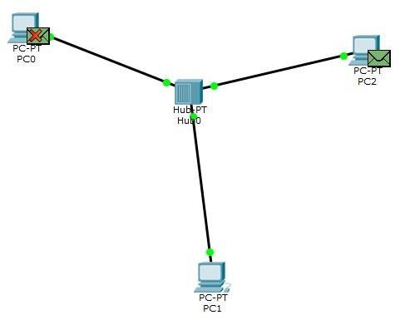

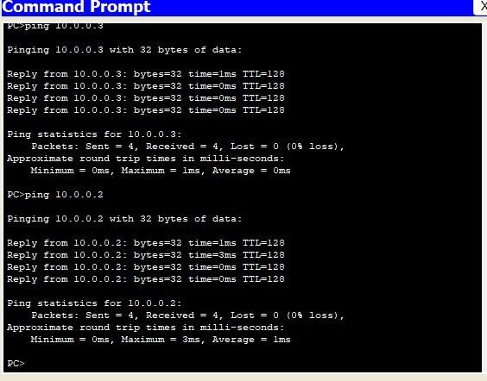

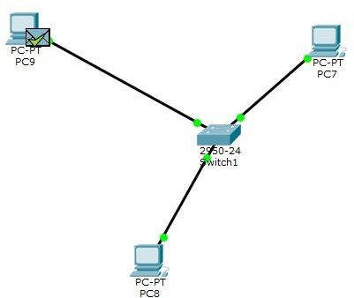

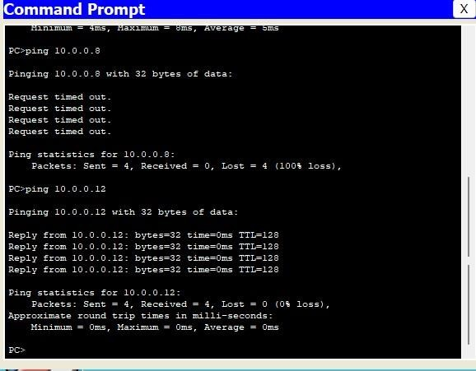

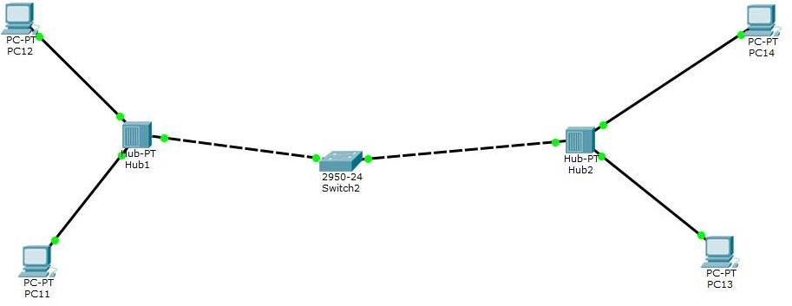

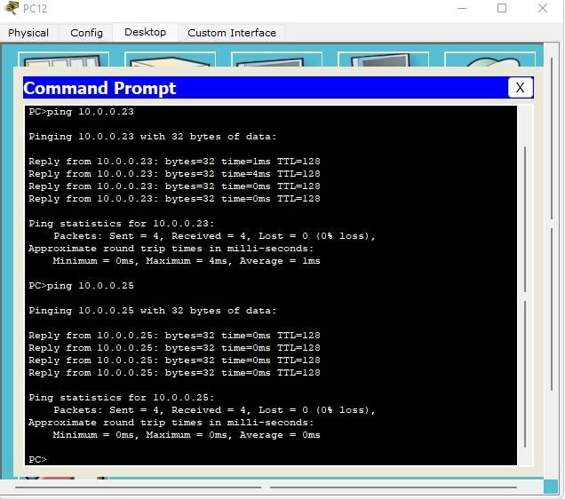

1. **Configure IP address to routers in packet tracer. Explore the following messages:ping responses, destination unreachable, request timed out, reply.**

## Topology:

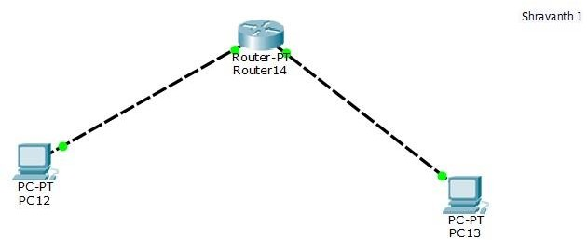

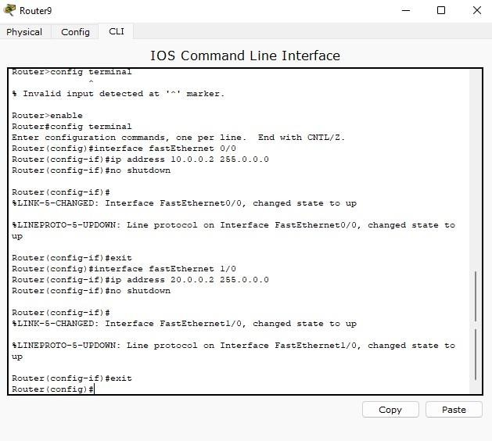

Now configure router interface with ip address and subnet mask then give no shutdown to make this interface and line protocol up(i.e. Carefully configure ip address with proper interfaces in this case f0/0 and f1/0,f is short form of fastethernet.

**Router(config)#interface fastEthernet 0/0 Router(config-if)#ip address 10.0.0.2 255.0.0.0 Router(config-if)#no shutdown**

**Router(config-if)#exit**

Interface Line protocol on FastEthernet0/0, changed state to up

**Router(config)#interface fastethernet 1/0 Router(config-if)#ip address 20.0.0.2 255.0.0.0 Router(config-if)#no shutdown**

**Router(config-if)#exit**

Interface Line protocol on FastEthernet1/0, changed state to up

Now lights on all ports become green from red.Now click on PC1->Desktop->Command Prompt. Now give this command "ping 20.0.0.1" and press enter.you will get,

connectivity between 10.0.0.1 and 20.0.0.1 is ok.Now PC1 communicates with PC2

Another way of checking connectivity is,select "simple PDU packet" from right side of packet tracer and select source PC and Destination PC.You will get response at right bottom of the pacter tracer window.

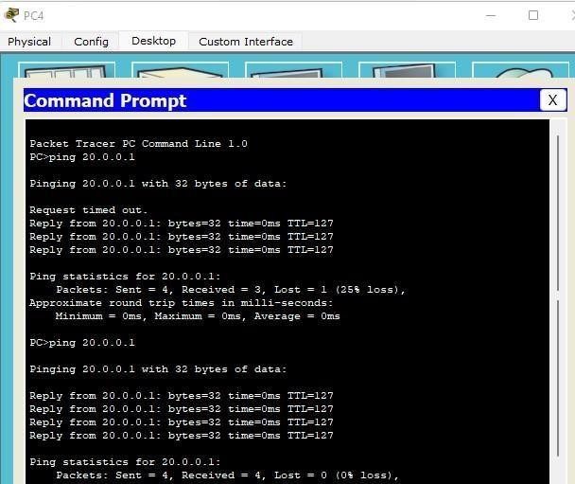

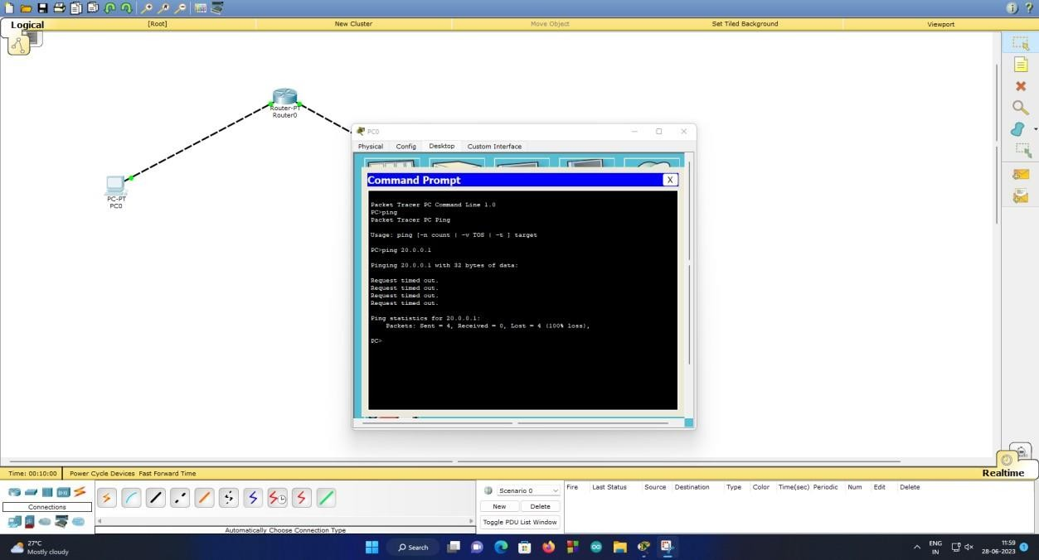

# Configure default, static route to the router. Static routing:

Topology Configure IP address and default gateway of PC’S Configure the routers as shown below

R0

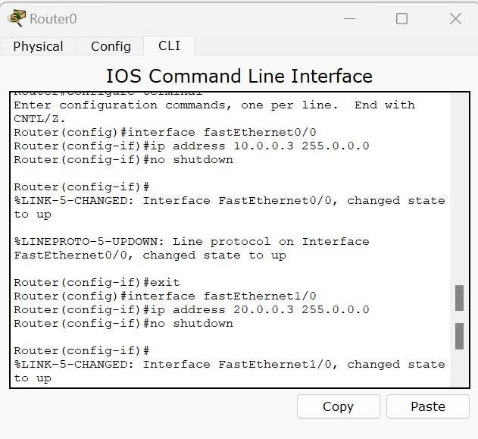

R2

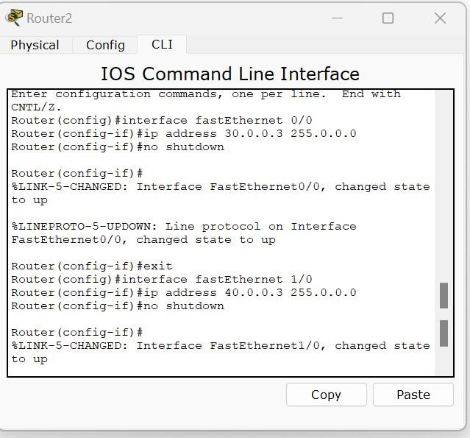

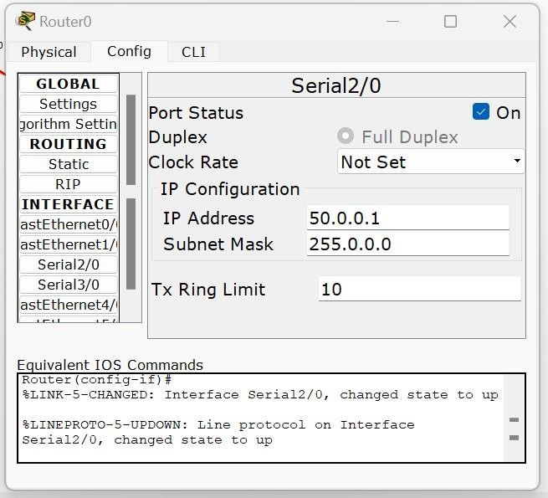

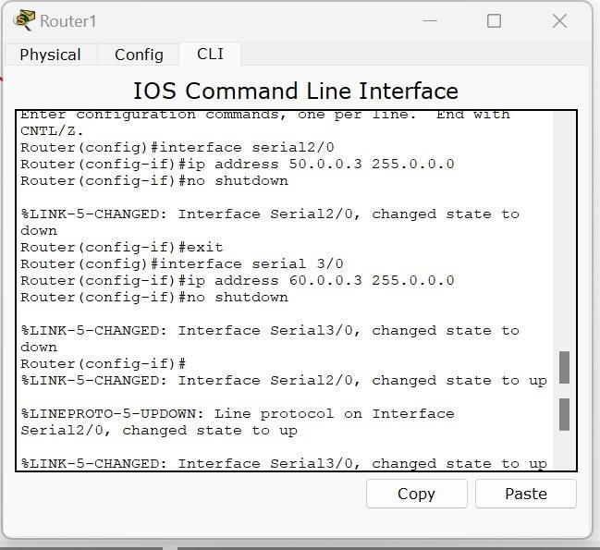

IP ROUTE COMMANDS

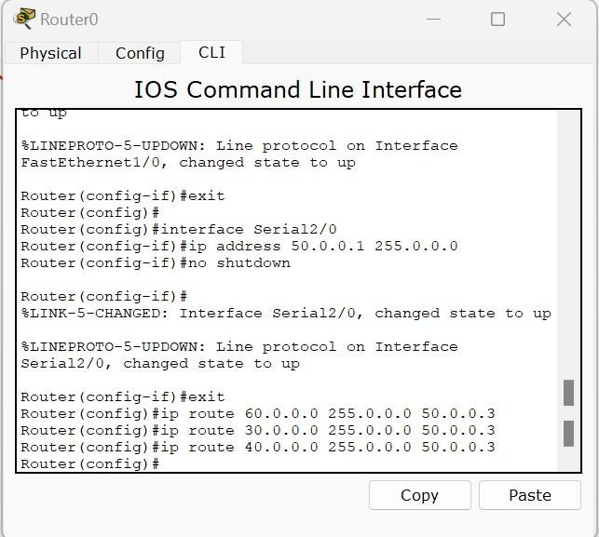

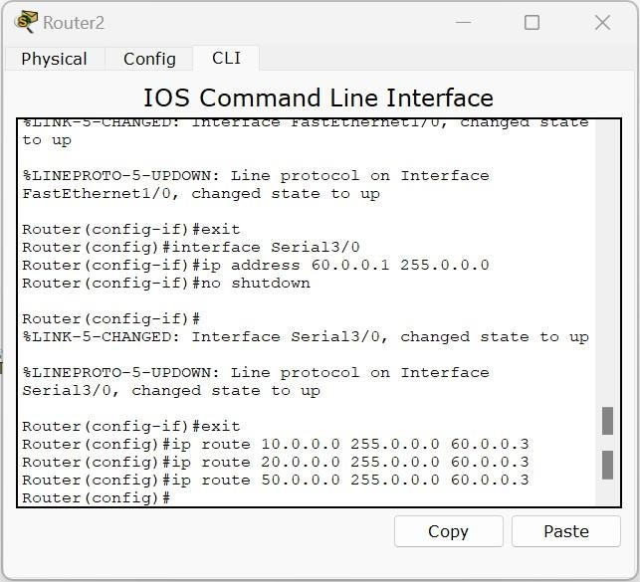

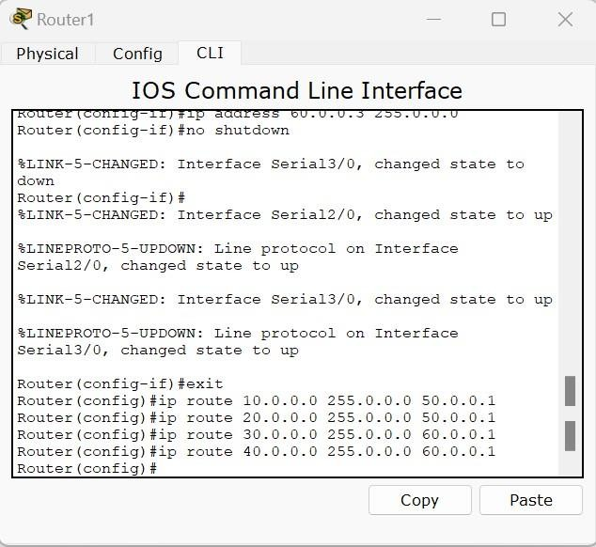

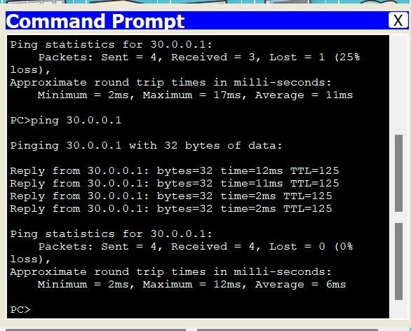

# Default routing

Set up topology as shown

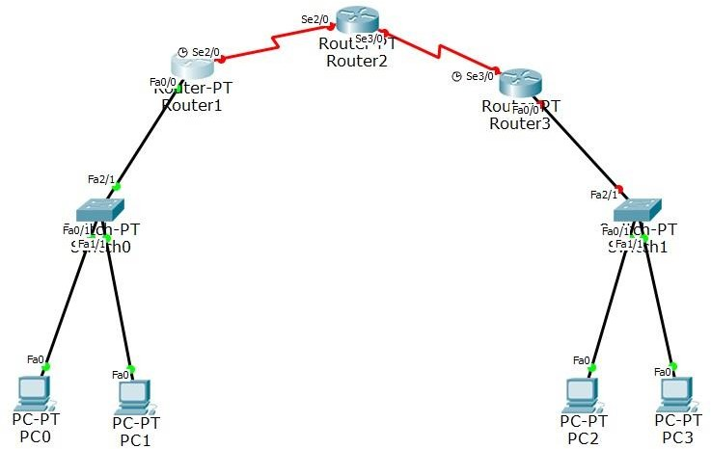

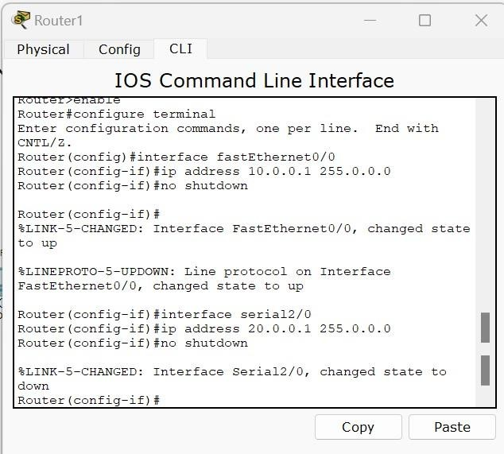

Router 2

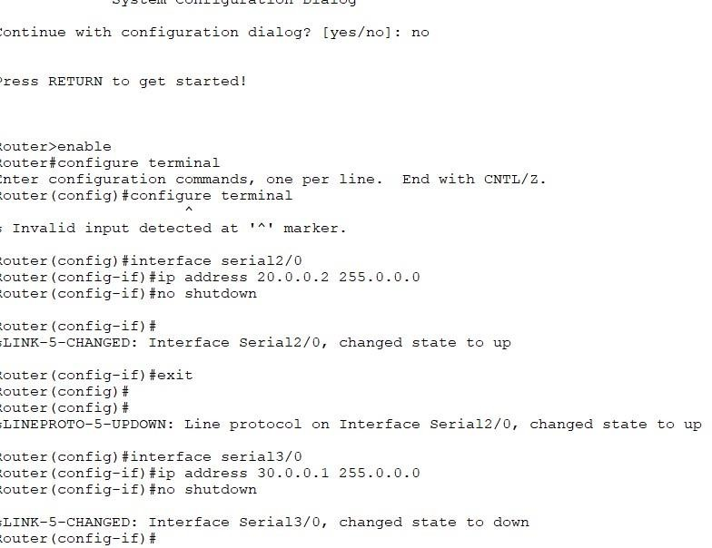

Router3

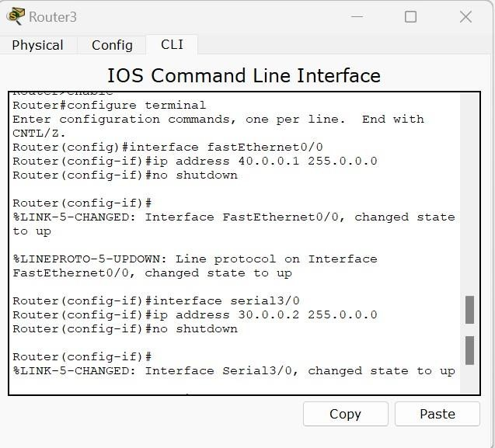

Configure static route for middle router R2 we have to do it for 40 & 10 network.

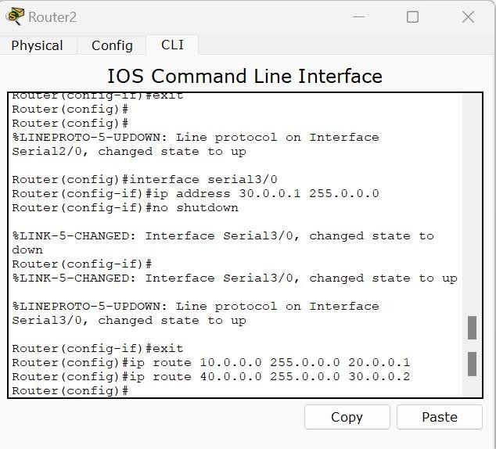

Default routing for router 1 and 3

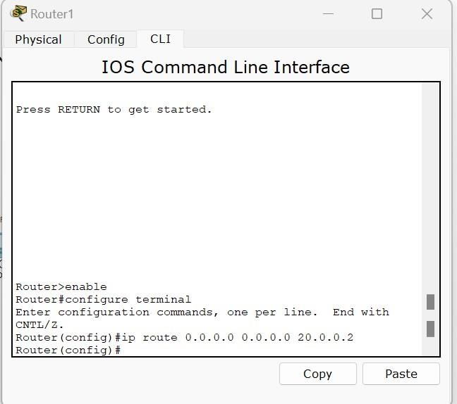

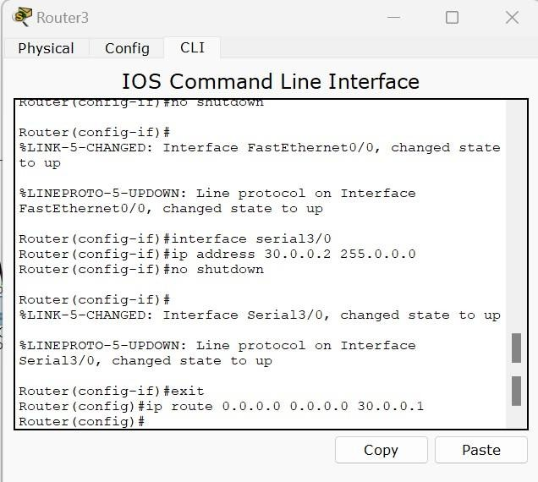

Ping from pc0 to pc2

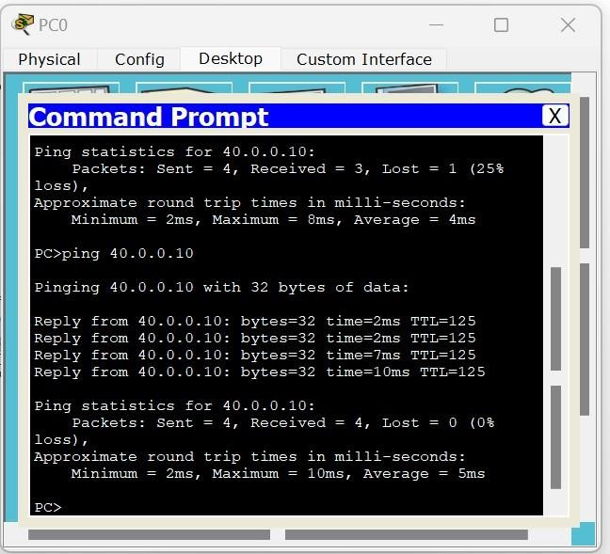

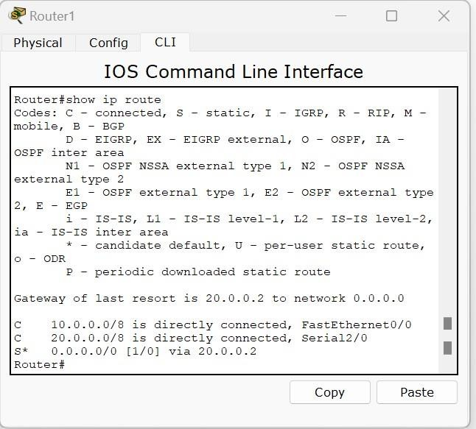

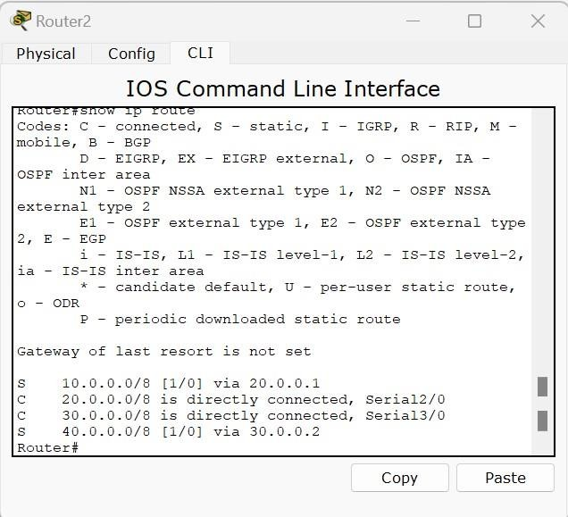

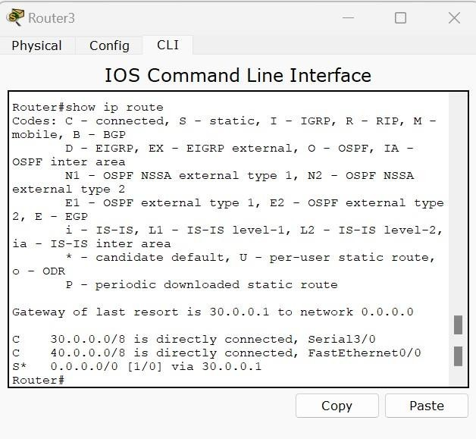

# Configure DHCP within a LAN and outside LAN.

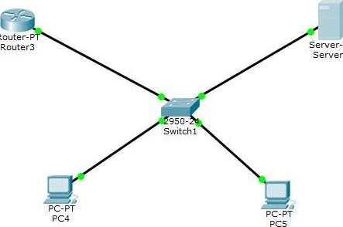

Router-

server-PT

**Step 1:**Create a LAN like this,

Router>enable Router #config t Router(config)

#interface fastethernet0/0 Router(config-if)

#ip address 10.0.0.1 255.0.0.0 Router(config-if) #no shutdown Router(config-if)

#exit Router(config)

**Step 3:**click on server-> config, then assign gateway in our example 10.0.0.1 **Step 4:**Then Click on Fastethernet and assign ip address and subnet mask.I am going to use 10.0.0.2 and subnet mask 255.0.0.0 for our server.

**Step 5:** Click on DHCP,there you can see default pool**,**

**Step 6:**Just give default gate way,here we are using 10.0.0.1.

**Step 7:**DNS server,Just give our server ip address,10.0.0.2.

**Step 8:**Then just edit start ip address.I am going to give 10.0.0.10 and subnet mask

255.0.0.0 **Step 9:**In Maximum Number of Users,Here we are using Class A Network so we can use 1,67,77,216 ip address.just give how many ip address you want in this pool.I am going to give 500

**Step 10:**Assign TFTP server ip address,just give our server ip address,10.0.0.2.

**Step 11:** And click on save.That's it...

**Step 12:**Now, Click on any of the PC-> then click on Desktop->Ip

ser.,erl

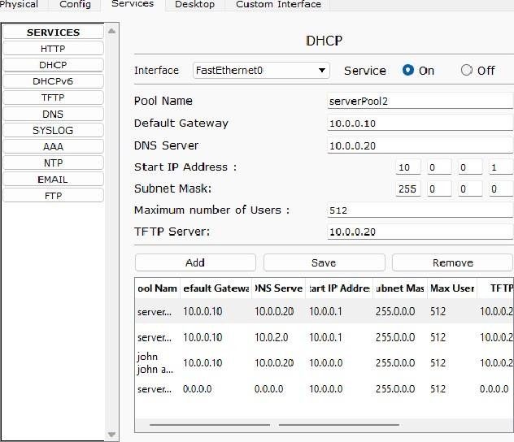

configuration,and Choose 'DHCP' wait for some time,if your dhcp request failed then try few more times.This is how you should get.

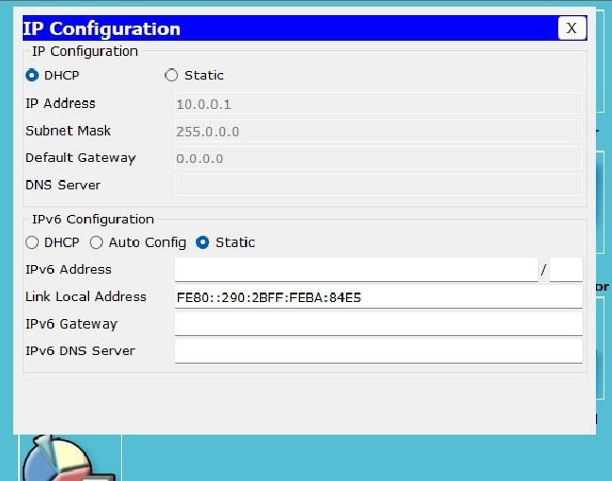

# DHCP outside LAN

Here we are going to see, how to configure DHCP for multiple netowrks .Can we get ip address from DHCP that is prensent in other network? yes we can.Lets see how to do with help of 'ip helper-address'.

**Step 1:**Create a topology like this,

**Step 2:**Configure the router interface fastethernet0/0 and fastethernet 0/1 with ip address .

Router>enable Router

#config terminal Router(config)

#interface fastethernet0/0 Router(config-if)

#ip address 10.0.0.1 255.0.0.0 Router(config-if) #no shutdown Router(config-if)

#exit Router(config)

#interface fastethernet0/1 Router(config-if)

#ip address 20.0.0.1 255.0.0.0 Router(config-if) #no shutdown Router(config-if)

#exit

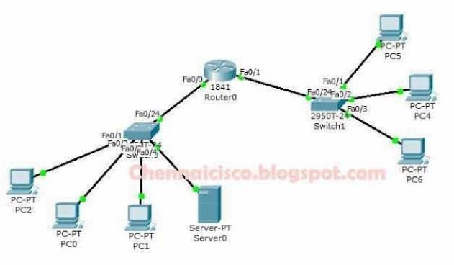

**Step 3:**Click on server->config->then just give the gateway ip address .Gateway for this network is 10.0.0.1

**Step 4:**Then click on fastethernet assign ip address.I am going to give 10.0.0.2 and subnetmask 255.0.0.0.Once we have configured the ip address for the server,DHCP server automatically assign 10 network for default pool.We don't have to create pool for 10 Network again.Just we need to give ip for DNS,Gateway and TFTP then we may

configure starting ip address or leave it and Save. **Step 5:**Now,Click on Pc in a LAN with Server and Check whether DHCP working fine in this network.Click on any PC>Desktop->Ip configuration->Choose DHCP, then you will get ip from dhcp server for this PC.

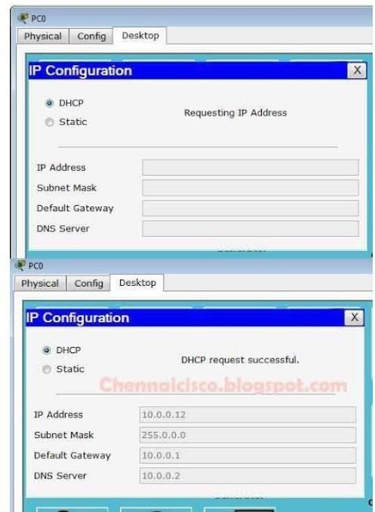

**Step 6:**Now,we see how to get ip address for PC that is in a network without Server.For that, first we have to add network pool in a dhcp server. So,Click on Server->Config->DHCP.

**Step 7:**Just edit Pool Name with any other name.I am going to give 20Network. Default Gateway->20.0.0.1, DNS Server->10.0.0.2

Start Ip Address->20.0.0.10 Subnet Mask->255.0.0.0 Maximun Number Of Users->100 TFTP Server10.0.0.2 Then,Click on Add and Save.

**Step 8**: Now go to router and give ip helper address under fastethernet0/1,that is server address here our server address is 10.0.0.2.Now we can get ip for this network also In Router,(Global configuration mode)

Router(config)#interface fastethernet0/1 Router(config-if)#ip helper-address 10.0.0.2 Router(config-if)#exit

**Step 9:**Now,check whether PC from network without server getting ip from the DHCP server in another Network.Click on any PC->Desktop->Ip configuration->Choose DHCP. Now we have got ip address from dhcp server.

# Configure RIP routing Protocol in Routers

TOPOLOGY

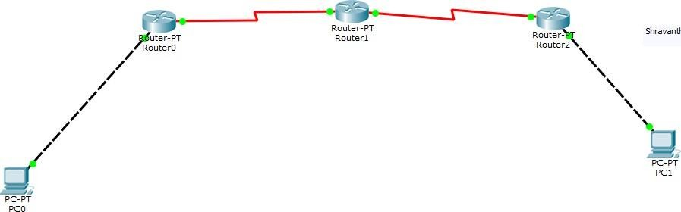

Configure ip address and gateway of PC’s Configure routers as shown in diagram.

Now configure ppp or point to point protocol for all routers.

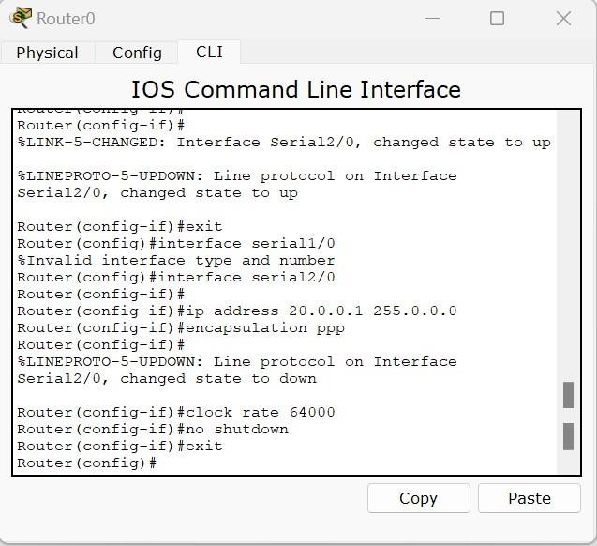

No need to give clk rate in second router

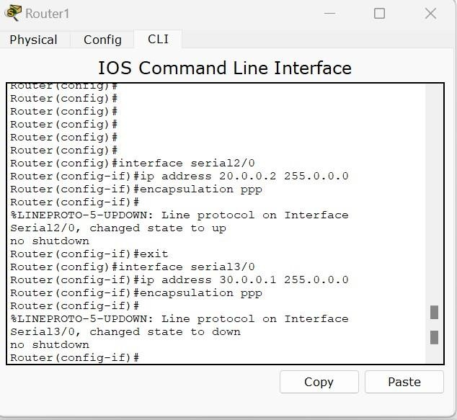

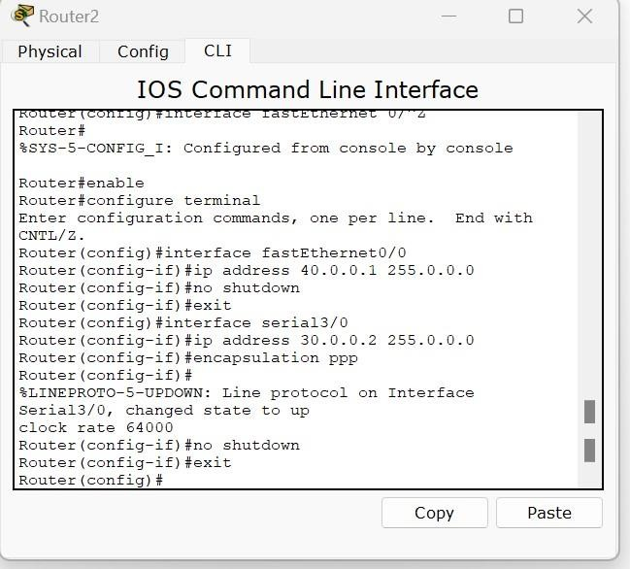

CONFIGURE RIP

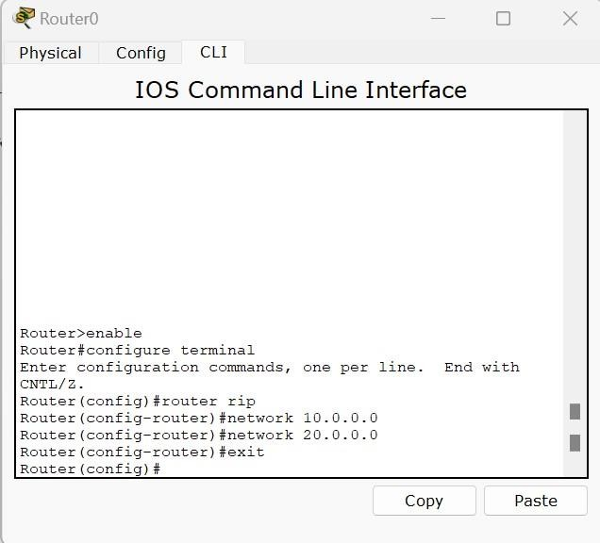

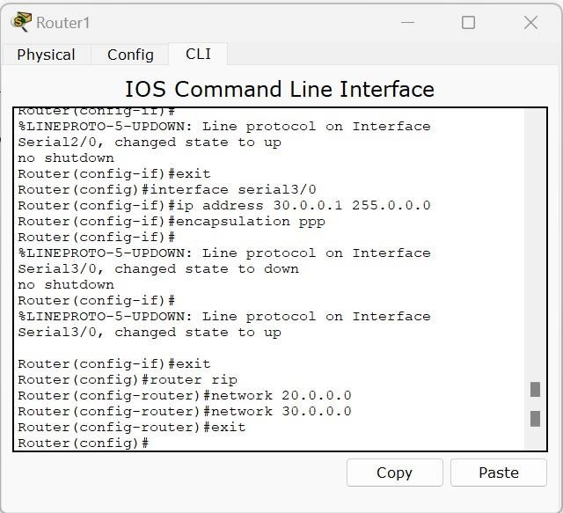

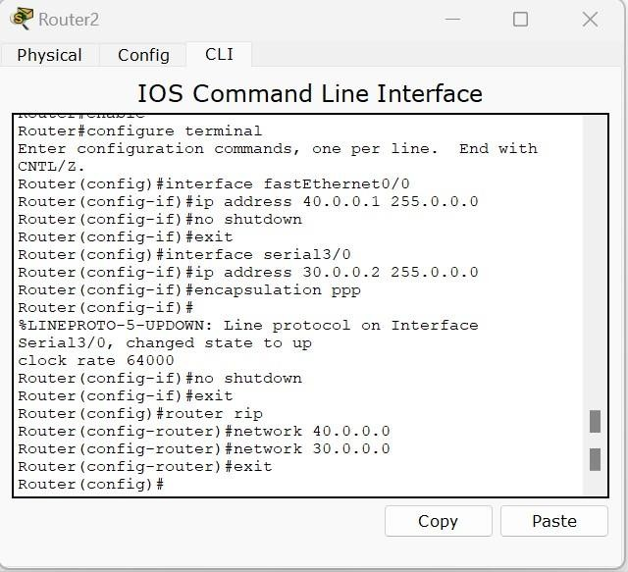

Execute show ip route

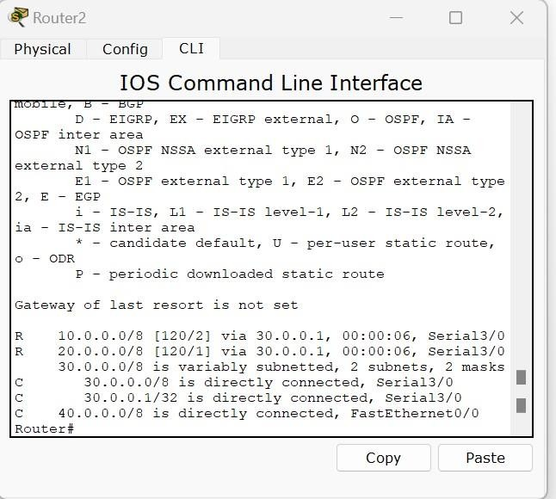

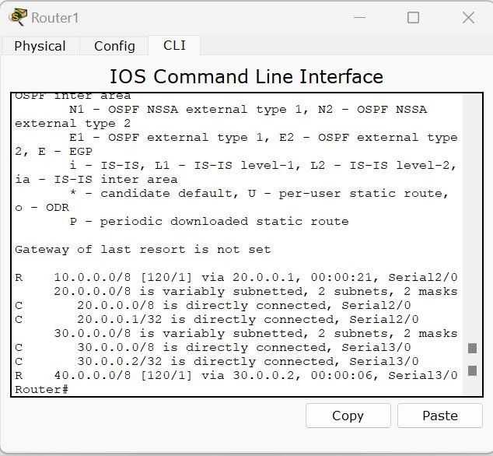

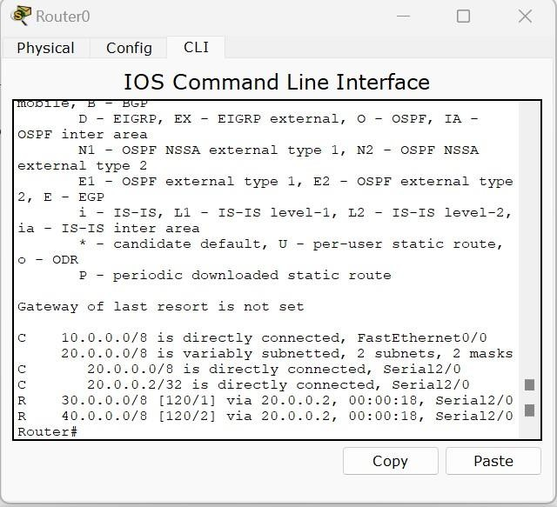

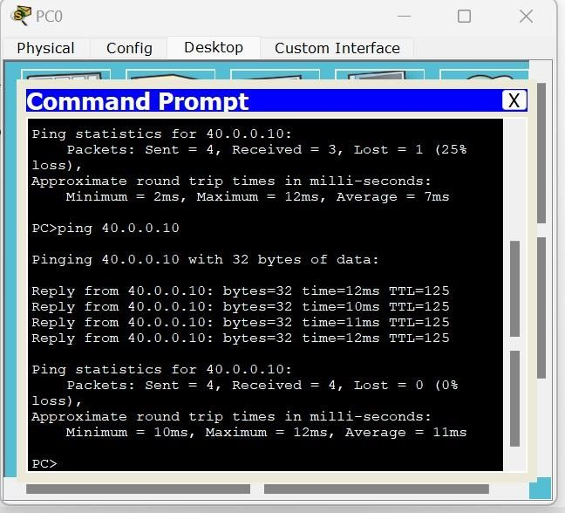

# Configure OSPF routing protocol

## Topology.

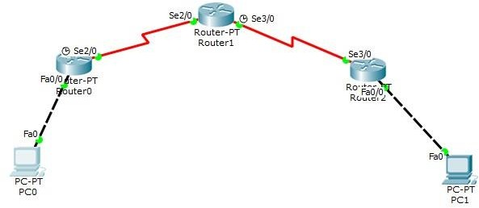

1. config rip.
2. Config ospf

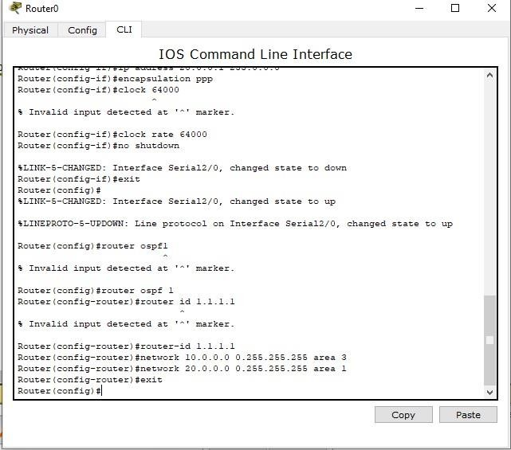

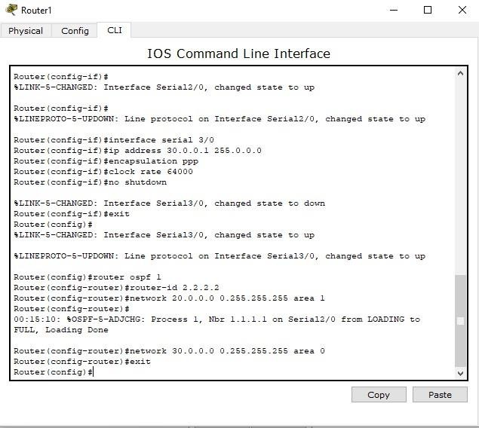

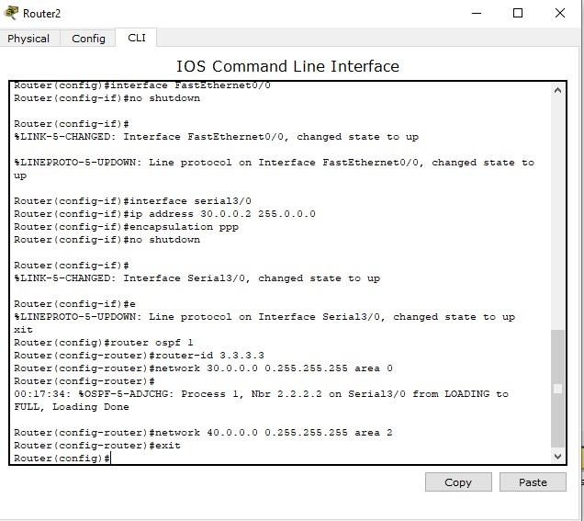

Show ip route

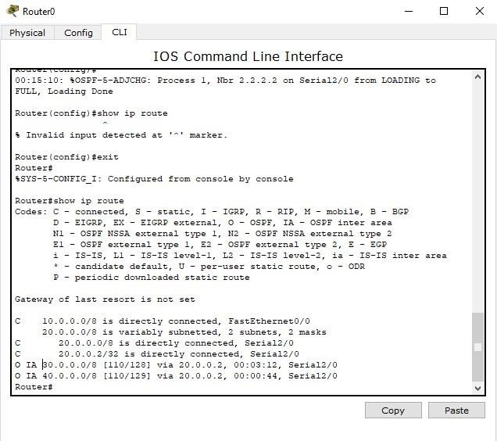

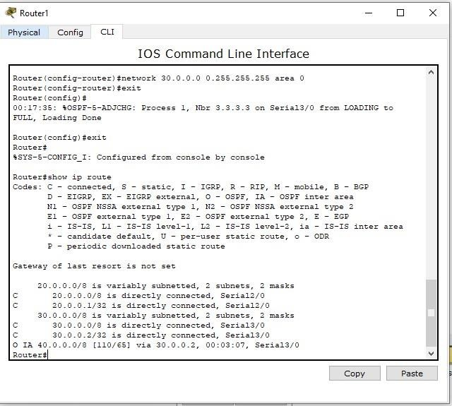

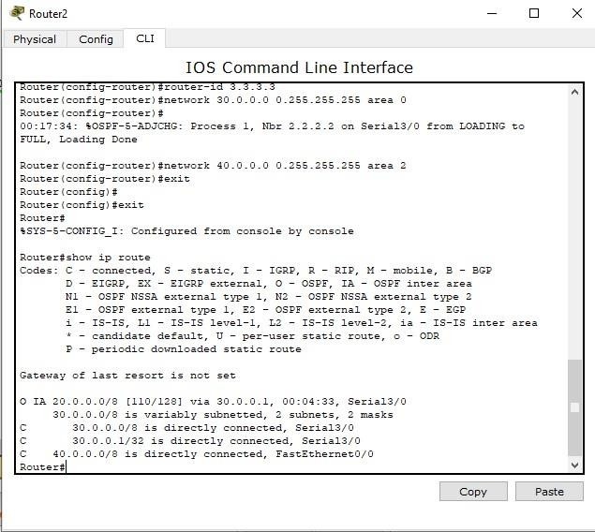

Loopback

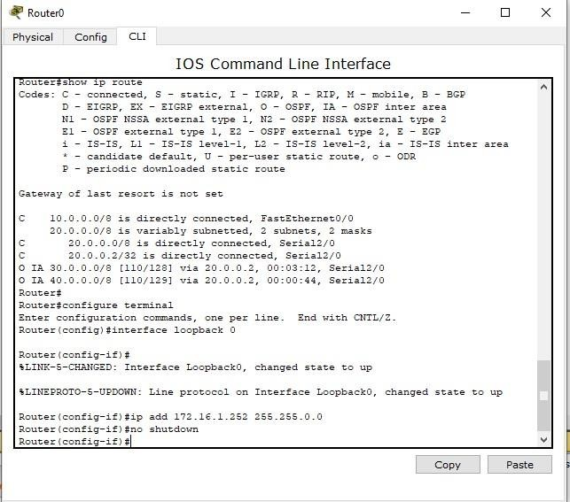

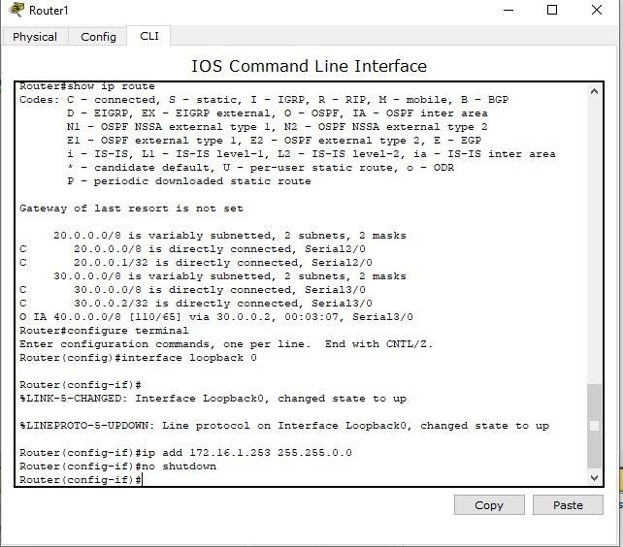

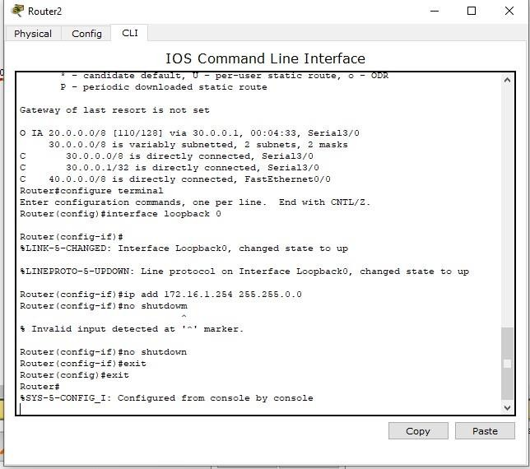

Show ip route for R2

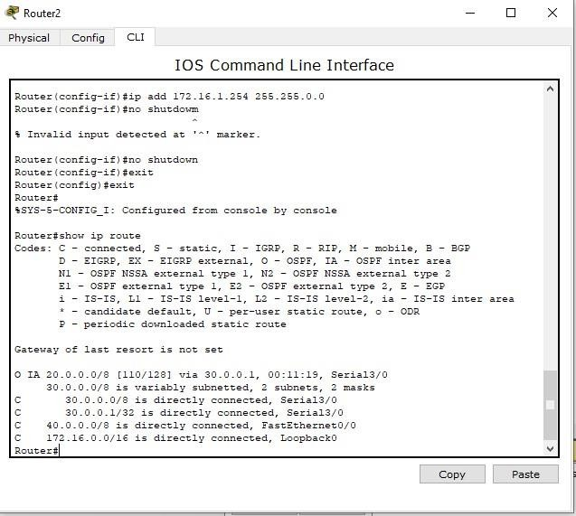

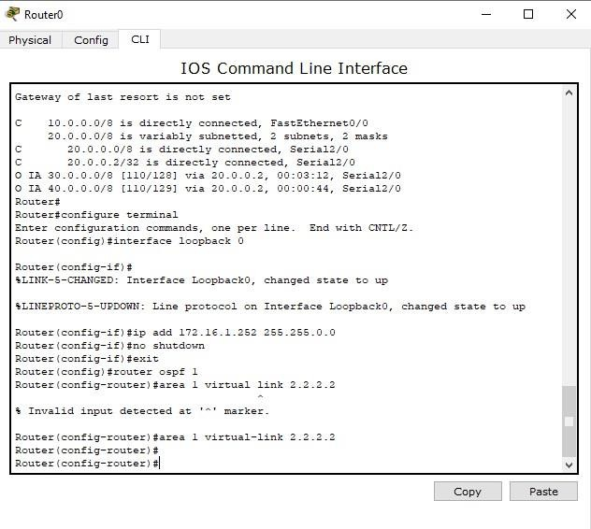

Similarly do for R1 you may face some disturbance while typing

Show ip route for R2

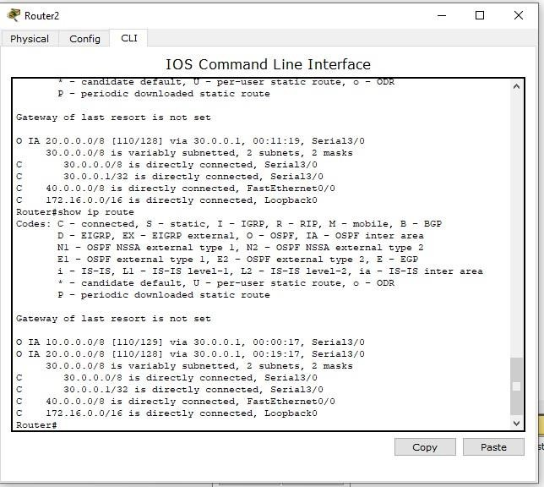

Ping 40.0.0.0 from 10.0.0.10

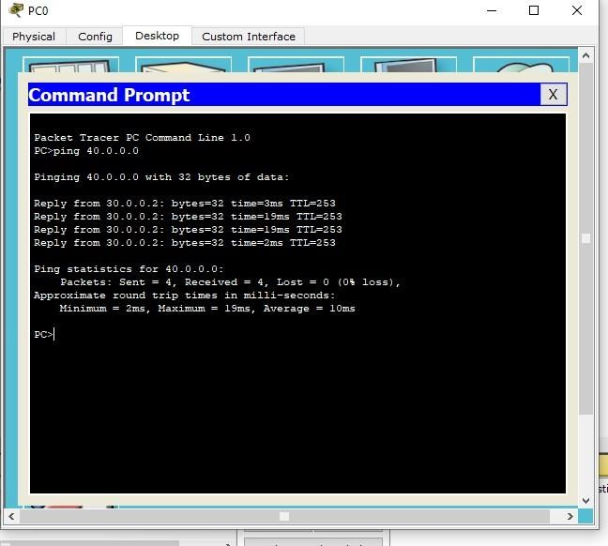

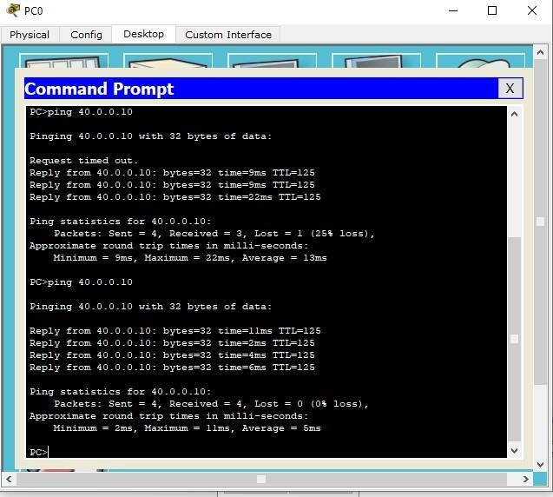

# Demonstrate the TTL/ Life of a Packet

Create a topology as shown below with two PCs and three routers. Configure the devices as per static / default / dynamic routing.

In the simulation mode, send a simple PDU from one PC to another. Use capture button to capture every transfer.

Click on the PDU during every transfer to see the Inbound and outbound PDU details.

Observe that there is a difference of 1 in TTL when it crosses every router.

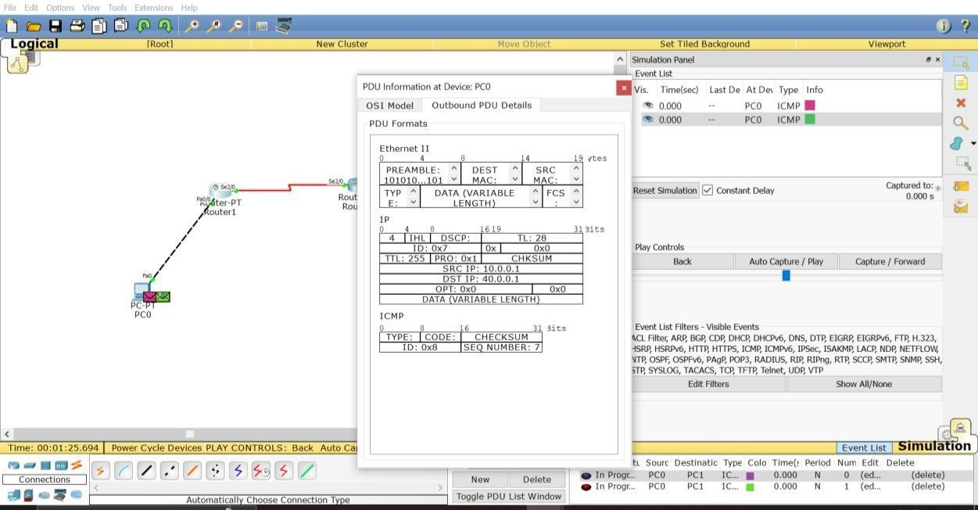

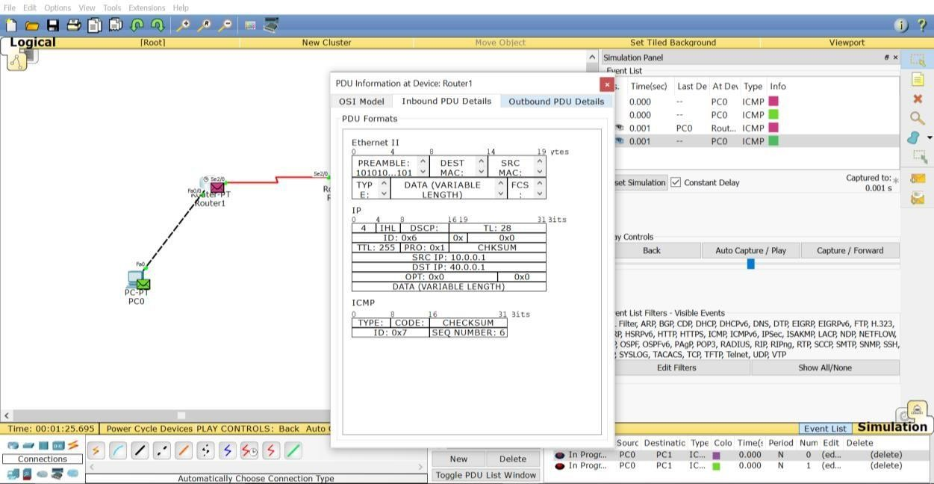

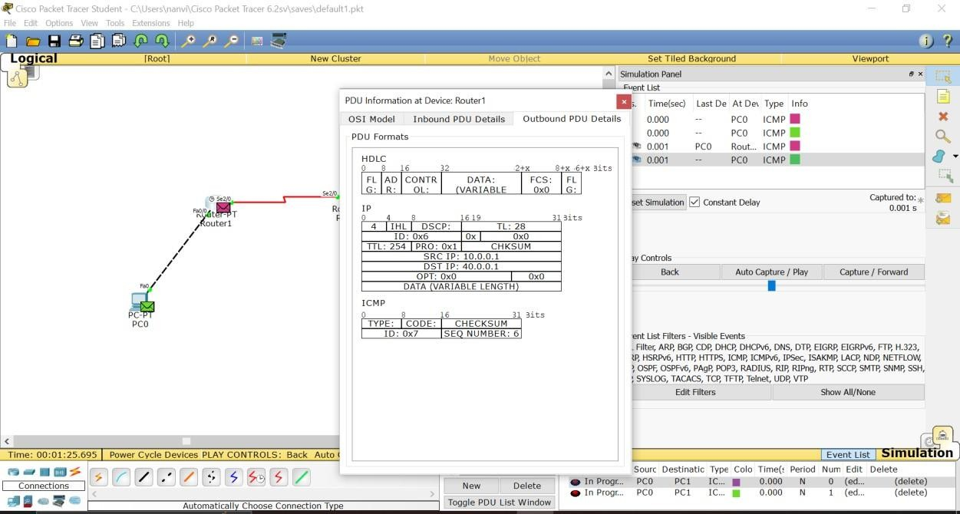

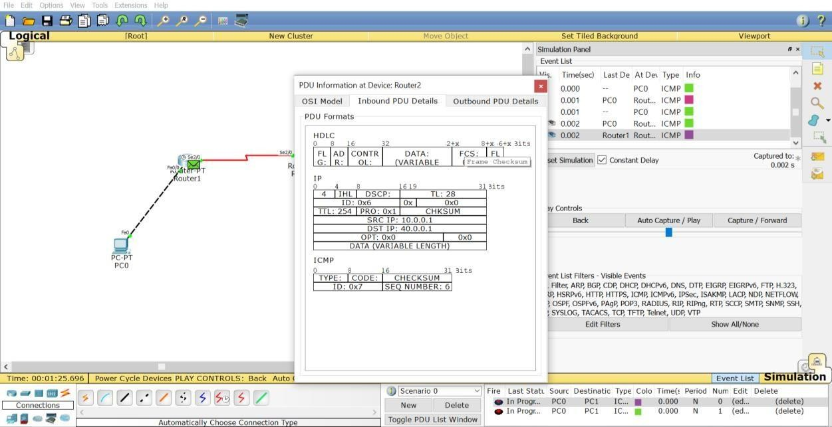

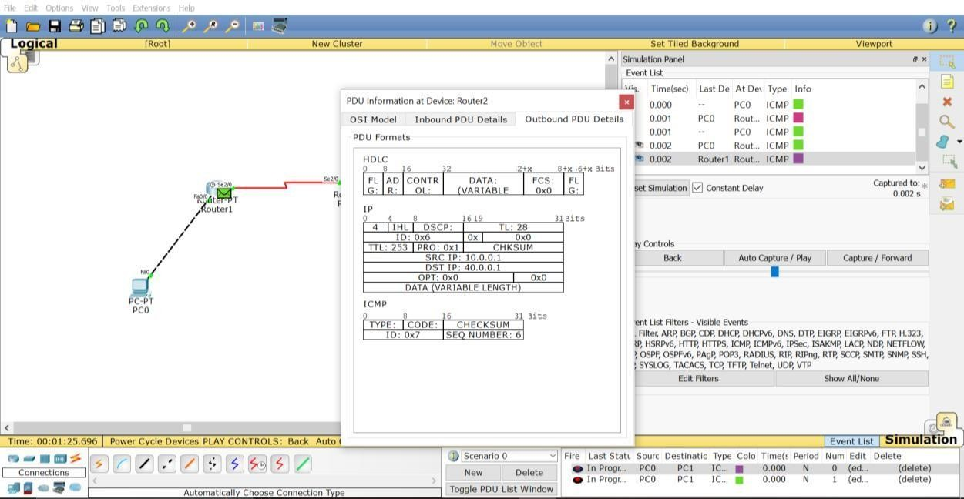

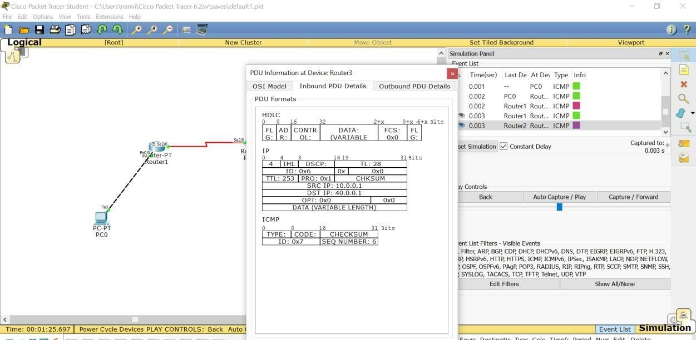

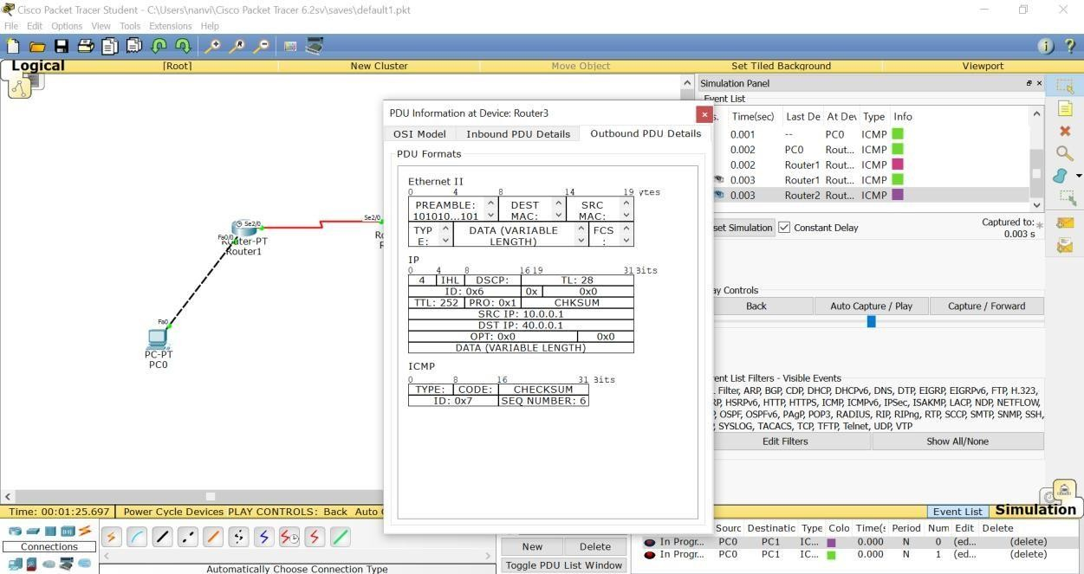

# Configure Web Server, DNS within a LAN. DNS

Topology:

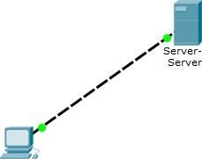

server-PT

r2

Configure ip address of PC-10.0.0.1 Server-10.0.0.2

Go to services in server select dns and add a new name as Vaishnavi Kamath and address as 10.0.0.2

address of your server.

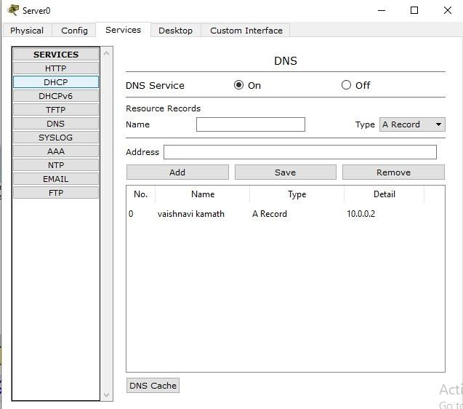

Go to http index.html and edit index page as shown below.

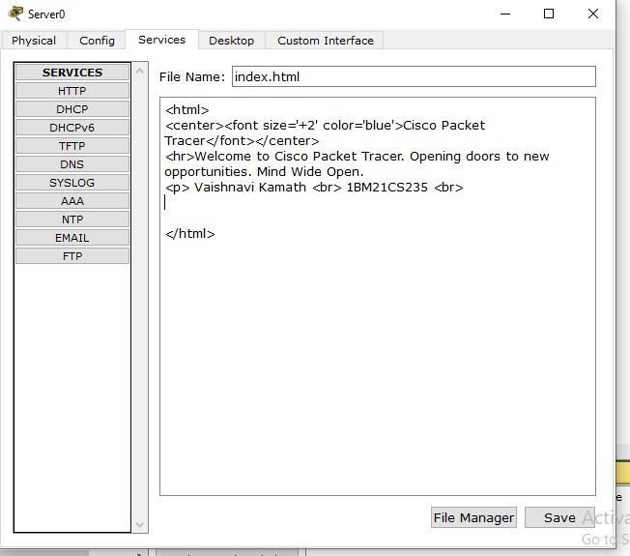

In PC go to desktop - Web browser and try to connect to server using server ip address. Output is shown (type 10.0.0.2)

Next type name which was given in server(vaishnavi kamath) and retry to connect. Following output is obtained.

# To construct simple LAN and understand the conceptand operation of

**Address Resolution Protocol (ARP)**

ARP

Topology

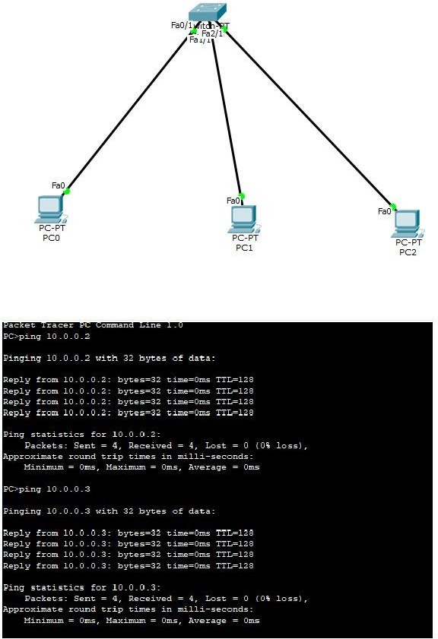

Configure ip address for pc. No default gateway for switches. Go to any pc cmd prompt and type as below

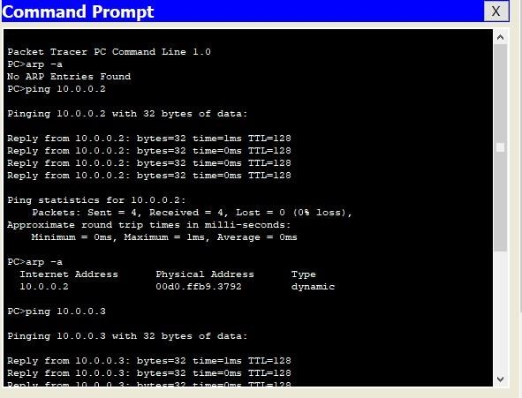

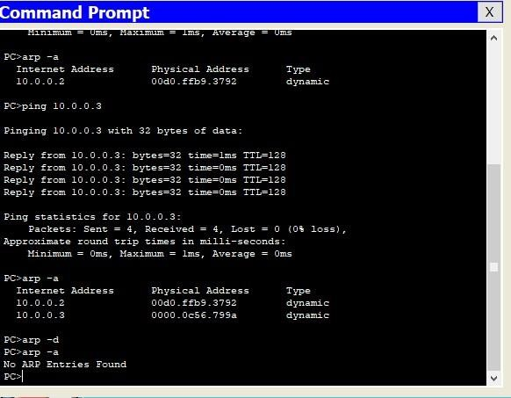

# To understand the operation of TELNET by accessing therouter in server room from a PC in IT off

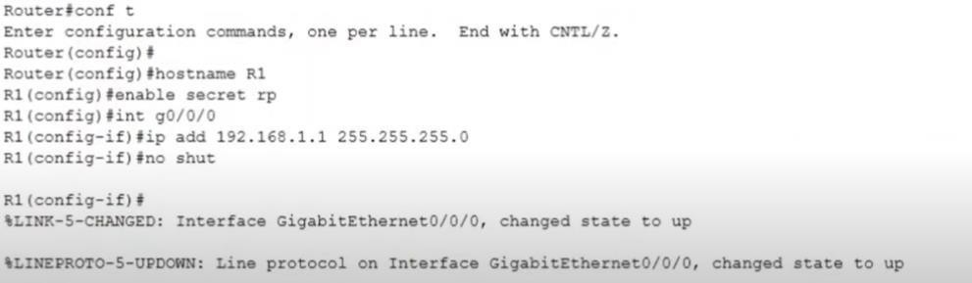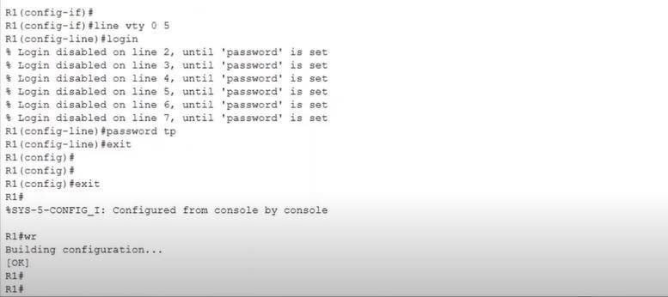

enable config t hostname R1 enable secret p1 interface fastethernet 0/0 ip address 10.0.0.1

255.0.0.0 no shut line vty 0 5 --to allow virtual terminal access for 6 users login password p0 exit exit wr – to save changes in router

### Commands in PC

In command prompt,

Ping 10.0.0.1

Ping results seen

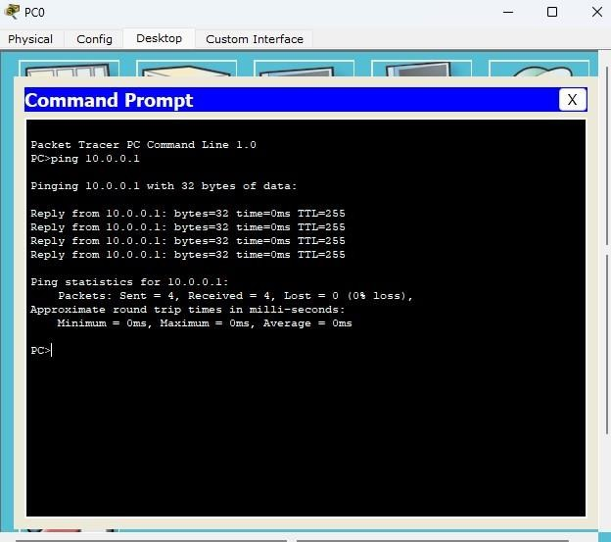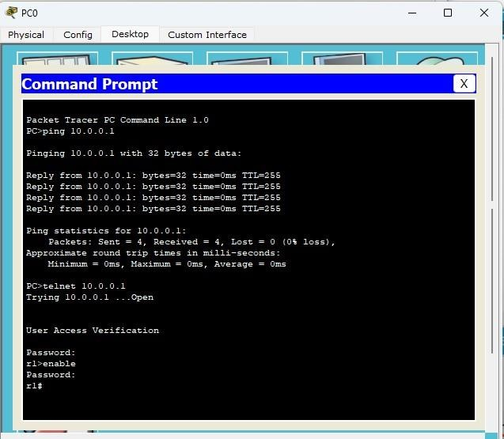

Password for User Access Verification is p0 Password for enable is p1

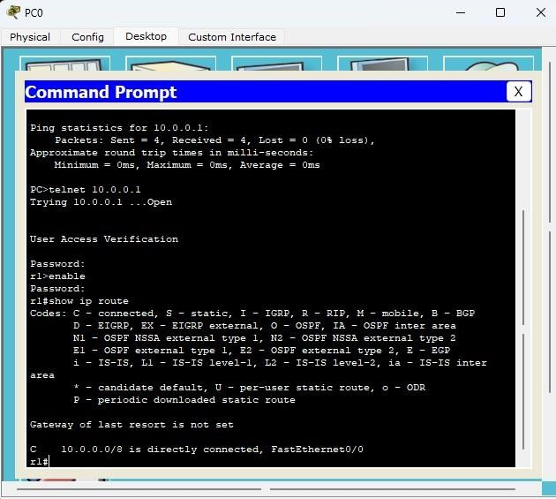Accessing router CLI from PC

The admin in PC is able to run commands as run in router CLI and see the result from PC.

# To construct a WLAN and make the nodes communicate wirelessly.

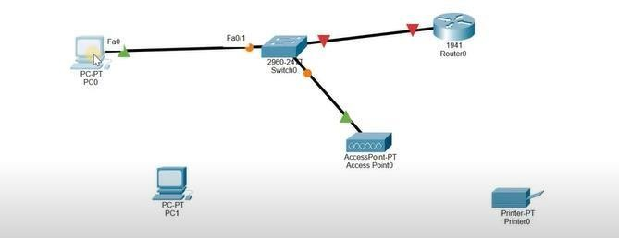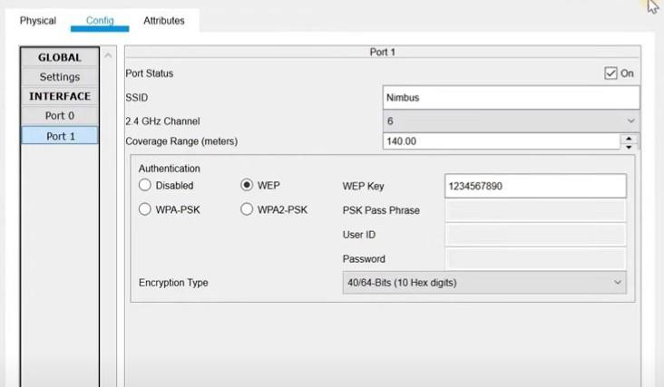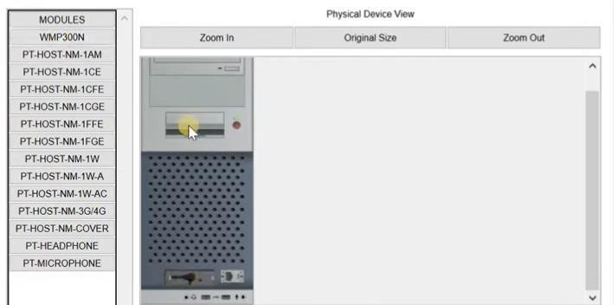

Construct the above topology

Configure PC3 and the Router1 as is normally done

Configure Access Point1- Port1 -> SSID Name- any name(WLAN here) Select WEP and give any 10 digit hex key – 1234567890 here

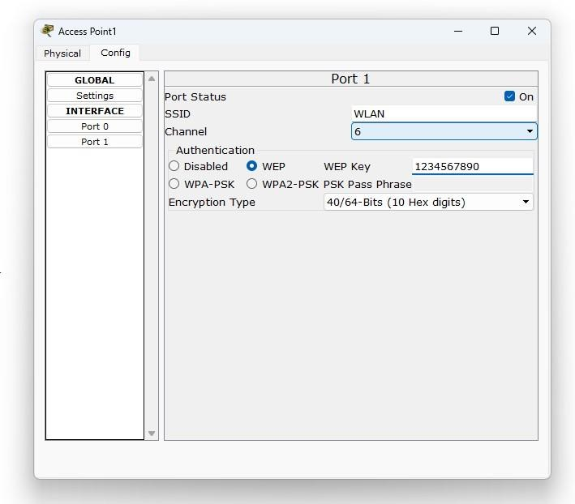

Configuring PC4 and Laptop with Wireless standards

Switch off the device. Drag the existing PT-HOST-NM-1AM to the component listed in the LHS. Drag WMP300N wireless interface to the empty port. Switch On the device.

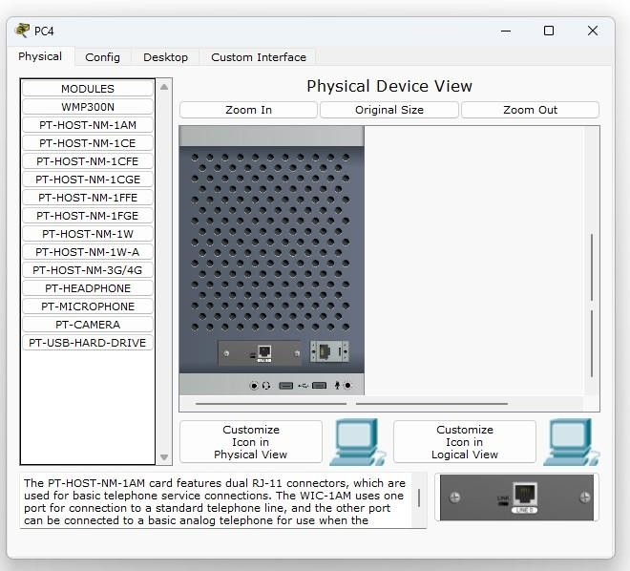

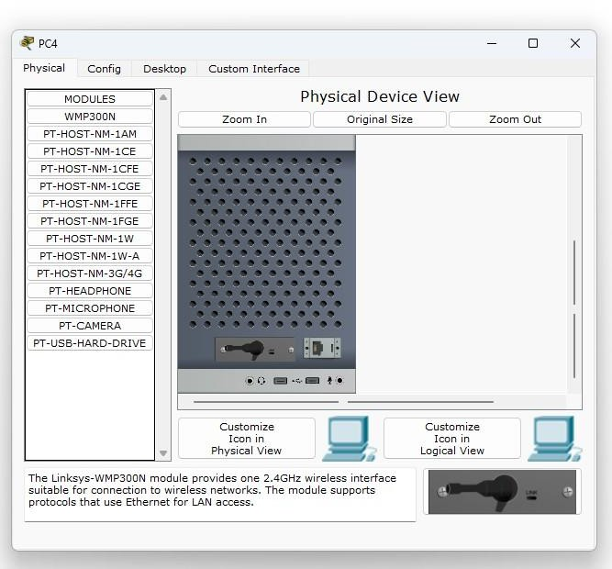

In the config tab a new wireless interface would have been added. Now configure SSID, WEP, WEP Key, IP address and **Gateway** (as normally done) to the device.

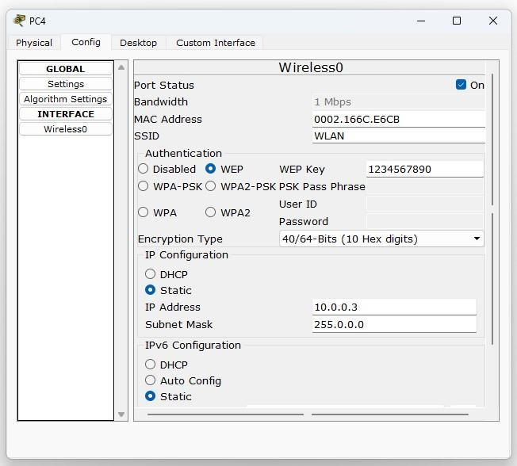

### Final topology on screen

Ping from every device to every other device and see the results

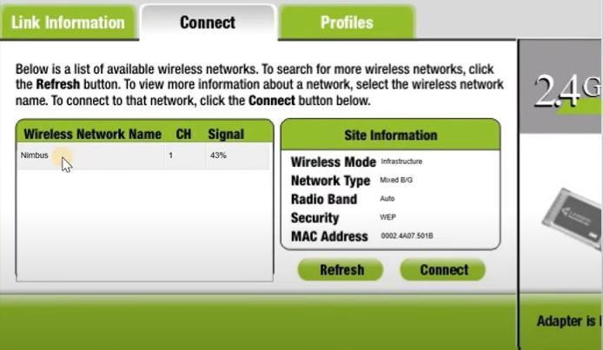

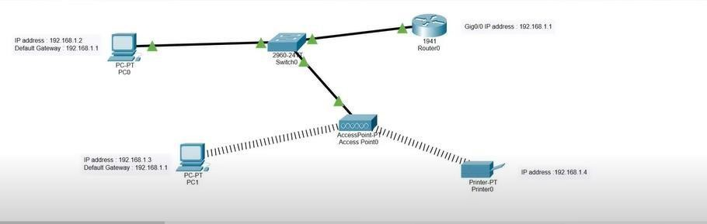

# To construct a VLAN and make the PC’s communicateamong a VLAN

## VLAN

TOPOLOGY

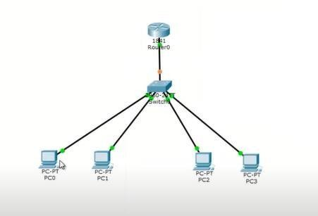

* 1. Connect pc’s as shown.Switch-2960 Router-1841
  2. Configure IP address and gateway to pc.
  3. Go to switch ->config->VLAN database set any VLAN name. But vlan number must be equal to the last but one number of the ip address (this must not be initially configured as the interface address of router) if we have 2 g/w as 192.168.1.1 and 192.168.20.1 and you have configured basically 192.168.1.1 for router interface then vlan number is 20.
  4. In switch select the interface which goes to router and set dropdown to trunk

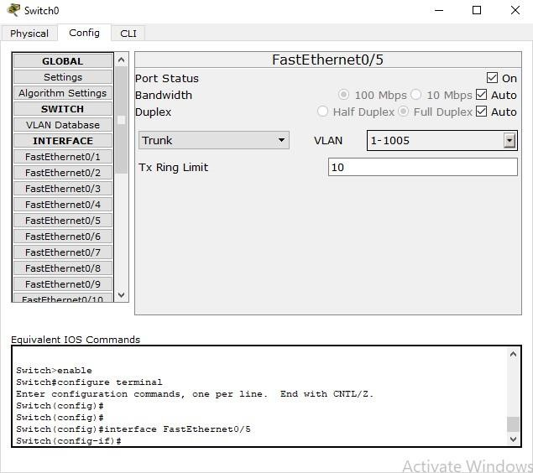

* 1. The right side sys conn to switch must be selected as vlan 20. Go to router and foll commands.

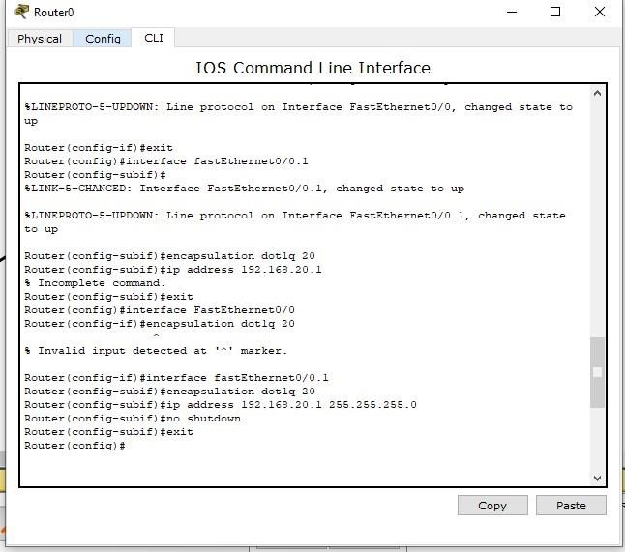

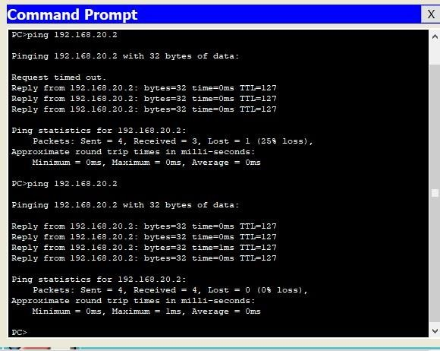

# CYCLE-II

1. **Write a program for congestion control using Leaky bucket algorithm.**

#include <stdio.h> #include <stdlib.h>

int main()

{

int buckets, outlets, k = 1, num, remaining; printf("Enter Bucket size and outstream size\n"); scanf("%d %d", &buckets, &outlets); remaining = buckets; while (k)

{

num = rand() % 1000; if(num < remaining)

{

remaining = remaining - num; printf("Packet of %d bytes accepted\n", num);

}

else

{

printf("Packet of %d bytes is discarded\n", num);

}

if (buckets - remaining > outlets)

{

remaining += outlets; // Fixed the calculation

}

else

remaining = buckets;

printf("Remaining bytes: %d \n", remaining);

printf("If you want to stop input, press 0, otherwise, press 1\n"); scanf("%d", &k);

}

while (remaining < buckets)

{ if (buckets - remaining > outlets)

{

remaining += outlets;

}

else remaining = buckets; printf("Remaining bytes: %d \n", remaining);

}

return 0;

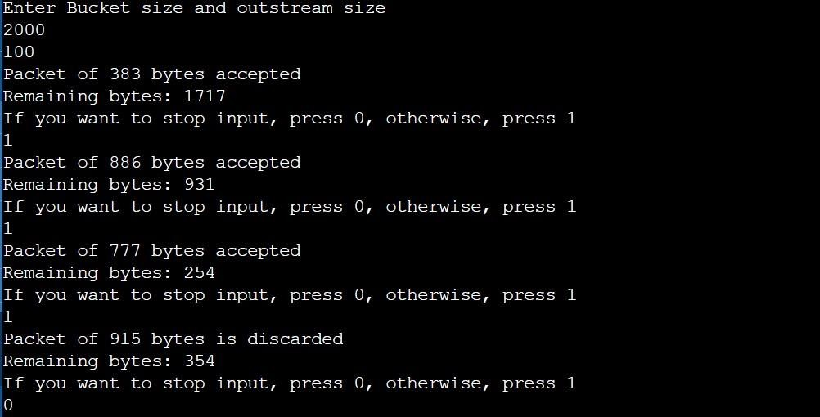}

# Using TCP/IP sockets, write a client-server program to make client sending the file name and the server to send back the contents of the requested file if present.

**Server.py**

from socket import * serverName= '127.0.0.1' serverPort= 12000 serverSocket= socket(AF_INET,SOCK_STREAM)

serverSocket.bind((serverName,serverPort)) serverSocket.listen(1) while True:

print("The Server is ready to receive") connectionSocket, addr = serverSocket.accept() sentence = connectionSocket.recv(1024).decode()

try:

file = open(sentence, "r") file_contents = file.read(1024) connectionSocket.send(file_contents.encode()) print("\nSent contents of " + sentence) file.close()

except FileNotFoundError:

error_message = "File not found" connectionSocket.send(error_message.encode())

connectionSocket.close()

### Client.py

serverName='127.0.0.1' serverPort=12000 clientSocket=socket(AF_INET, SOCK_STREAM) clientSocket.connect((serverName,serverPort)) sentence=input("\nEnter file name: ") clientSocket.send(sentence.encode()) filecontents=clientSocket.recv(1024).decode() print('\nFrom Server:\n') print(filecontents) clientSocket.close()

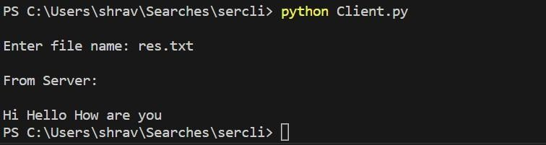

# Using UDP sockets, write a client-server program to make client sending the file name and the server to send back the contents of the requested file if present.

### Server.py

socket import *

serverPort = 12000 serverSocket = socket(AF_INET, SOCK_DGRAM) serverSocket.bind(('127.0.0.1', serverPort)) print('The server is ready to receive')

while True:

sentence, clientAddress = serverSocket.recvfrom(2048) sentence = sentence.decode('utf-8')

try:

file = open(sentence, "r") content = file.read(2048)

serverSocket.sendto(bytes(content, 'utf-8'), clientAddress) print('\nSent contents of', sentence)

file.close()

except FileNotFoundError: error_message = "File not found"

serverSocket.sendto(bytes(error_message, 'utf-8'), clientAddress) print('\nFile not found:', sentence)

### Client.py

from socket import *

serverName = '127.0.0.1' serverPort = 12000 clientSocket = socket(AF_INET, SOCK_DGRAM) try: sentence = input('\nEnter file name: ')

clientSocket.sendto(bytes(sentence, 'utf-8'), (serverName, serverPort)) filecontents, serverAddress = clientSocket.recvfrom(2048)

if filecontents.decode('utf-8') == "File not found": print('\nFile not found on the server.')

else:

print('\nReply from Server:\n') print(filecontents.decode('utf8')) except Exception as e:

print(f"An error occurred: {str(e)}")

finally:

clientSocket.close()

OUTPUT

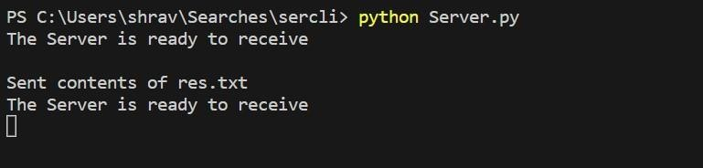

# Write a program for error detecting code using CRCCCITT (16-bits).

#include<stdio.h> char m[50],g[50],r[50],q[50],temp[50];

void caltrans(int); void crc(int); void calram(); void shiftl(); int main()

{

int n,i=0; char ch,flag=0; printf("Enter the frame bits:"); while((ch=getc(stdin))!='\n') m[i++]=ch; n=i; for(i=0;i<16;i++) m[n++]='0'; m[n]='\0'; printf("Message after appending 16 zeros:%s",m); for(i=0;i<=16;i++)

g[i]='0'; g[0]=g[4]=g[11]=g[16]='1';g[17]

='\0';

printf("\ngenerator:%s\n",g); crc(n); printf("\n\nquotient:%s",q); caltrans(n); printf("\ntransmitted frame:%s",m); printf("\nEnter transmitted freme:"); scanf("\n%s",m); printf("CRC checking\n"); crc(n); printf("\n\nlast remainder:%s",r); for(i=0;i<16;i++)

if(r[i]!='0')

flag=1; else continue; if(flag==1) printf("Error during transmission"); else printf("\n\nReceived freme is correct");

}

void crc(int n)

{ int i,j;

for(i=0;i<n;i++) temp[i]=m[i];

for(i=0;i<16;i++) r[i]=m[i]; printf("\nintermediate remainder\n"); for(i=0;i<n-16;i++)

{ if(r[0]=='1'

)

{ q[i]='1';

calram();

}

else

{ q[i]='0';

shiftl();

} r[16]=

m[17+i

];

r[17]='\0'; printf("\nremainder

%d:%s",i+1,r);

for(j=0;j<=17;j++) temp[j]=r[j];

}

q[n-16]='\0';

}

void calram()

{ int i,j;

for(i=1;i<=16;i++) r[i-1]=((int)temp[i]- 48)^((int)g[i]-48)+48;

} void shiftl()

{

int i;

for(i=1;i<=16;i++) r[i- 1]=r[i];

}

void caltrans(int n)

{

int i,k=0; for(i=n-16;i<n;i++) m[i]=((int)m[i]-48)^((int)r[k++]- 48)+48; m[i]='\0';

}

OUTPUT

